**21 Sept 2018** **The Weekly Bulletin of Rotary Club of Kathmandu Mid-Town** **bc-3.9/018**

|  |
| --- |
| C:\Users\Public\Documents\RIP T1819_EN.png |

District: 3292 Web:www.rotarymidtown.org.np Club Id: 26776

**SEPTEMBER IS THE BASIC EDUCATION AND LITERACY MONTH**

**Basic education and literacy is one of Rotary’s six areas of focus.**

Using research-based approaches, Rotary members work to enhance the quality of basic primary and secondary education and instruction, as well as to empower educators to engage and inspire more children - particularly girls - and adults to learn.

The Rotary Foundation offers opportunities to support:

■ Enhancements to primary and secondary schools ■ Adult literacy education

■ Programs that train teachers ■ Improvements to education materials and curriculum delivery systems

■ Vocational training teams supporting these and other educational activities

■ Scholarships for graduate-level study in programs related to basic education and literacy

Source: Rotary org

**Club Meeting # 1457** : 14 Sept 018

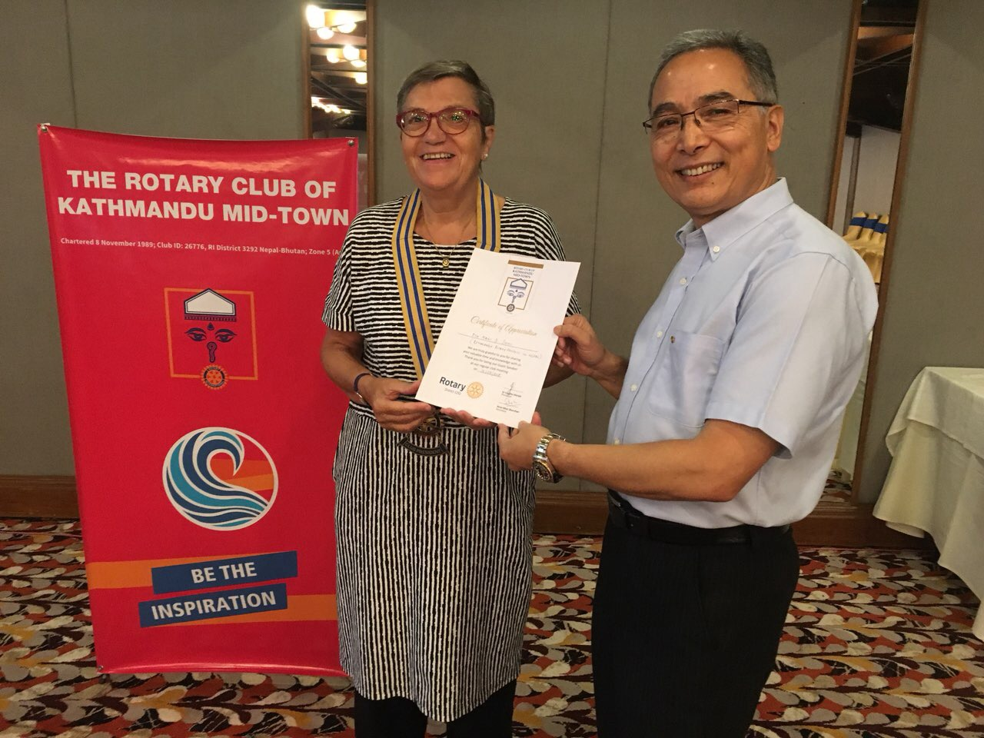

Inhouse speaker PP Mani D Joshi receiving

a certificate of appreciation from Club President Jo

Inhouse speaker PP Mani D Joshi, before beginning his

talk, appreciated “What a wonderful event it is - a new

Rotarian (Susen A. Molé) has just been inducted to the Club,

and I see a couple of guests (prospective?) including some

erstwhile Rotaractors attending this meeting, and here

I am to talk on Rotary!”

Talking on ‘Rotary in Nepal’ within just 20-25 minutes is

another challenge, he admitted.

The speaker went through some important points and events

of Rotary in Nepal.

He elaborated a little more on Bhaktapur Cancer Hospital,

ANM project and Gift of Sight.

**New Member Induction**

In a brief Induction program Ms Susen A Mole is inducted to Rotary Club of Kathmandu Mid-Town.

President Jo requested Rtn Shyam R Thapaliya and he provided a brief introduction of Susen to the audience. She is from Chambersburg, PA, USA and currently working in Scheer Memorial Adventist Hospital as the Special Projects Officer. Mid-Towner Dale Mole is her spouse.

PP Gopal SL Kakshapati conducted the induction program in accordance with the given Rotary procedure. He welcomed Susen on behalf of the Club, gave a brief introduction of Rotary, what it is and what it is not, informed why she was chosen for membership and hoped she would carry forward the principles and ideals of service as a Club member.

President Jo pinned Susen with a Rotary badge and welcomed her to the Club as a newest Rotarian of the world. Club members congratulated Susen and welcomed her to the Club with a big round of applause.

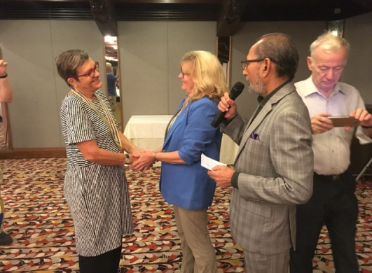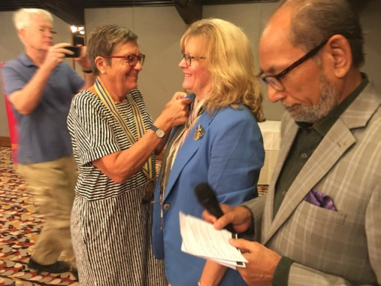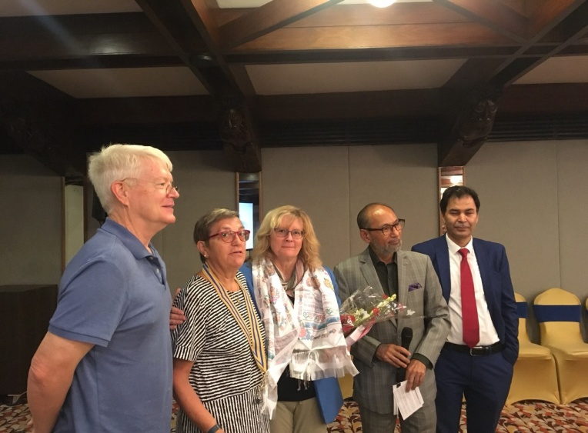

# Weekly Meeting/Program Schedule:

|  |  |  |
| --- | --- | --- |
| Date | Program/ Speaker | Topic of Presentation |
| 21 September | Installation | 29th Installation of the Club |

Friday Meeting: 21 Sept

29th Installation of the Club is going to be held on Friday 21 Sept

Venue : Malla Hotel, Thamel

Timing : 18:00 hrs onward

A program sheet is given as annex on page # 5

**Program at Navakiran Children Home:** On Saturday 15 September 2018

President Jo and Secretary Arun along with a group of Rotarians from Rotary Club of Kathmandu visited Navakiran Children Home at Hattiban in a program of handing over 20 mattresses for children and a cheque amounting to Rs 500,000 for roofing material/works.

**Be the Inspiration**: DG Chintamani Bhattarai, DS Rajendra Shakya and DS Gen Sharad Neupane joined the program despite their time pressure.

DG Chintamani and Patron of Navakiran Mother Sabitri Pokharel jointly unveiled a Plaque acknowledging the financial support provided for earthquake rehabilitation (2015-018) by RC Livermore CA/USA, RC Milano Veloresi, Italy and RC Kathmandu Mid-Town.

DG Chintamani handed over the cheque to Mother Sabitri Pokharel. Mattresses were jointly handed over by Adhir Chipalu/DG Chintamani to Mother Sabitri/SG Parash Pokharel.

Navakiran children chanted “Happy Birth Day” and other blessings to Adhir

PP Paras Rana (RC KMT) and Secretary General Parash Pokharel jointly coordinated the program.

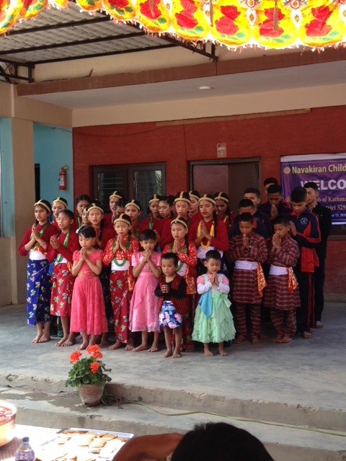 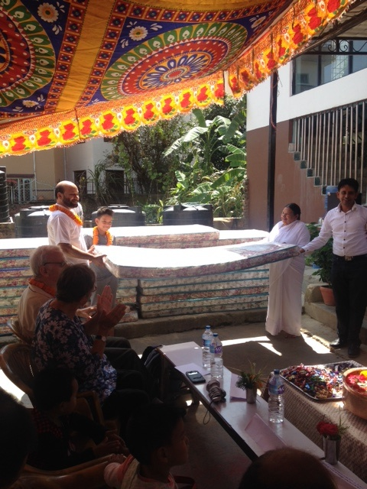

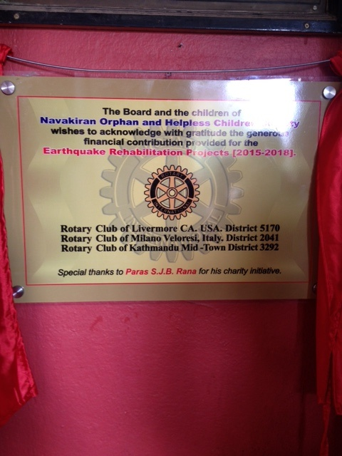 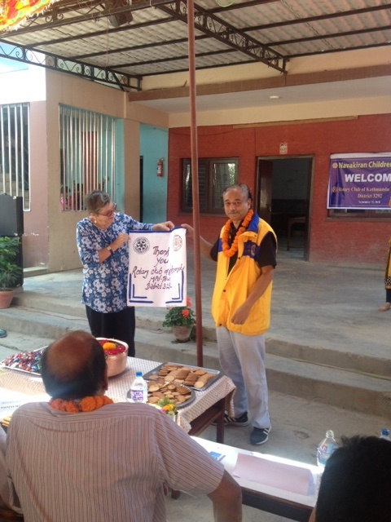

**Club innovation: Corporate citizens:**

After weighing corporate membership models to energize its roster, the club (DeMotte Rotary) chose an approach pioneered by other clubs in District 6540 and turned to local businesses to sponsor employees as Rotarians. Nine members and counting have signed on under the program, which provides the newcomers flexibility in attendance. Their employers pay club, district, and RI dues.

Deann Patena’s knowledge of Rotary came from her job booking meeting space for a large hotel and entertainment complex that served as the home base of the Rotary Club of Merrillville, Indiana.

In October 2017, a month after she started her new position, Patena’s supervisor asked if she would be the farm’s representative to the DeMotte Rotary Club. “I did not ever think I would be a Rotarian,” says Patena, but she accepted because she wanted to meet local business leaders. And her company would be covering the fees.

The enlistment of the farm and other corporate sponsors was the work of club member Dan Ryan, 2018-19 governor of District 6540. He credits the Rotary Club of Portage, Indiana, for laying out the options that work for DeMotte: Companies pay the monthly dues for the employee representatives. The attendance rules depend on the number of employees registered: two meetings per month for one company representative, or one meeting monthly for each of two representatives. The newcomers are full-fledged Rotarians. “We wanted every corporate member to be a Rotarian and have every right and privilege of being a Rotarian,” Ryan says.

Ryan believes the infusion of new spirit has paid dividends for his club. “They bring an energy, and they bring more hands to projects,” he says. “We had gotten older as a club, so you’re not able to do the projects like you used to when you were 20 years younger.” And for sponsoring businesses, the benefit is immeasurable. “One advantage is serving the community,” Ryan says, “but also offering your employees leadership training and the opportunity to network and to be mentored by older businesspeople in the community.”

*https://www.rotary.org/en/club-innovation-corporate-memberships*

**Corporate membership for Rotary?**

If the pilot program being carried out in some countries of the Rotary world is a success, Rotary International may soon open its doors to corporate membership.

*Source: Rotary News April 2018*

**A THOUGHT FOR TODAY:**

**[A life spent making mistakes is not only more honorable,](http://www.brainyquote.com/quotes/quotes/g/georgebern102967.html" \o "view quote)**

**[but more useful than a life spent doing nothing.](http://www.brainyquote.com/quotes/quotes/g/georgebern102967.html" \o "view quote)**

[***[George Bernard Shaw](http://thinkexist.com/quotation/knowing_a_great_deal_is_not_the_same_as_being/198021.html)***](http://www.brainyquote.com/quotes/authors/g/george_bernard_shaw.html)

**Committee Chairs’ Column:** *(This column is for use by chairpersons of 5 permanent committees: Club Administration, Membership, Public Relations, Service Projects, and the Rotary Foundation)*

**Members’ Corner:** *(This column is for Club members to express anything they would like in matter of Club activities, Club administration, Club issues or on Breakfast Chatter, or on anything else that would be of interest to fellow members.)*

**Do you know?**

[Precious metals](https://www.eso.org/public/archives/releases/sciencepapers/eso1733/eso1733e.pdf)on earth, such as gold and platinum, may have originated in the stars.Scientists confirmed this after detecting a titanic collision of two super-dense neutron stars 130 million light years from Earth.

*The Irish Time*

**Photos source:**

*Courtsey:* All photos excepting those of Navakiran program, are from Rtn Shyam R Thapalia. Many thanks!

On Lighter Side:

After just a few years of marriage, filled with constant arguments, Banta and his wife Preeto decided the only way to save their marriage was to try counseling. They had been at each other’s throat for some time and felt that this was their last straw. When they arrived at the counselor’s office, the counselor jumped right in and opened the floor for discussion. “What seems to be the problem?”

Banta held his long face down without anything to say. On the other hand, Preeto began talking non-stop describing all the wrongs within their marriage.

After 10-15 minutes of listening to the wife, the counselor went over to her, picked her up by her shoulders, and kissed her passionately. Afterwards, Preeto sat there, speechless.

She looked over at Banta who was staring in disbelief at what had happened.

The counselor spoke to Banta, “Your wife needs that at least twice a week!”

Banta scratched his head and replied, “I can have her here on Wednesdays and Saturdays!”

.

**On Rotary:**

The *Engaging Younger Professionals Toolkit* at Rotary.org has an action plan to help you reach young leaders and Rotary alumni in your area.

Truly sustainable service, the kind of service we strive for in Rotary, means looking at everything we

do as part of a larger global ecology…. The environment plays a key role in all six of our areas of

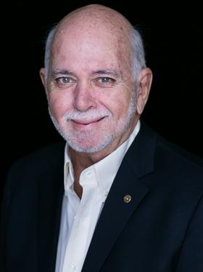

focus, and that role is only becoming greater as the impact of climate change unfolds. It’s time to

move past seeing the environment as somehow separate from those six areas. Clean air, water, and

land are essential for healthy communities – and essential for the better, healthier future we strive

for.

**RI President Barry Rassin**

Please send information on club activities, progress reviews on service projects, relevant photos etc to:

BC Editor: RR Shrestha email: rryesrr@gmail.com

## 21 Sept 2018 The Weekly Bulletin of Rotary Club of Kathmandu Mid-Town bc-3.9/018

Annex

Rotary Club of Kathmandu Mid-Town

29th Installation Function

21st September 2018

PROGRAMME

6.00 - 6.30pm :  Fellowships

6.30 - 7.30pm :  Meeting

|  |  |
| --- | --- |
| **Dignitaries on the Dais** |  |
| Rtn Sanjay Giri | Immediate Past Governor 2017-018 |
| Rtn Chintamani Bhattarai | District Governor 2018-19, Chief Guest |
| Rtn Jo Logghe Sherpa | President |
| Rtn Bhairaja Panday | Immediate Past President |
| Rtn Arun Man Sherchan | Secretary |

1. Presentation of *Khadas* to dignitaries;  bouquets to DG and first lady by the spouses of Past Presidents

2. Welcome Address by AG PP Mani Joshi “Lighting the lamp” by Chief Guest DG Chintamani Bhattarai.

3. Address and presentation of mementos by IPP Bhairaja Panday

4. Introduction of President Rtn. Jo Logghe Sherpa by PDG Yogendra Pradhan

5. Presentation of  gavel, gong and presidential collar by IPP Bhairaja Pandaytoincoming Pres Jo Logghe Sherpa

6. Presentation of Club Charter by Mani Joshi to incoming President Jo Logghe Sherpa.

7. Administering the Oath of Office to Pres Rtn Jo Logghe Sherpa by DG Chintamani Bhattarai

8. Meeting #1458 Called to Order by President Rtn Jo Logghe Sherpa

9. Silent invocation

10. Welcoming District Officials, Rotarians, Spouses and Guests (please introduce your guests)

11. Announcement of birthdays and wedding anniversaries by the sergeant-at-arms Rtn Dr Rabindra Shrestha.

12. Granting leave of absence to:

13. Approval of Minutes #1457

14. Acceptance speech by President Rtn Jo Logghe Sherpa

15. Introduction of  the new Board (2018-19) by President Rtn Jo Logghe Sherpa

16. Administering Oath of Office to new office bearers by Pres Rtn Jo Logghe Sherpa and presentation of their office pins by DG Chintamani Bhattarai

17. Token of Appreciation to IPP Rtn Bhairaya Panday by Pres Jo Logghe Sherpa

18. Bouquet to IPP First Lady Mrs Panday by Mr Sherpa Spouse of Pres Rtn Jo Logghe Sherpa

19. Address by Chief Guest District Governor Rtn Chintamani Bhattarai

20. Presentation of memento to District Governor Rtn. Chintamani Bhattarai by Pres Jo Logghe Sherpa

21. Vote of Thanks by secretary

22. Toast by IPP Rtn Bhairaja Panday for the  wellbeing of President Bidhya Devi Bhandari and the People of Nepal

23. Toast by President Rtn  Jo Logghe Sherpa for all Rotary District Officials, for  all Rotarians in Nepal and for the global Rotary fraternity

24. Adjournment of the meeting #1458 by President Jo Logghe Sherpa

Cocktails and fellowship dinner